 | Mizān – A Workload Management Web App  Phase 1 – Web App Design and Implementation (weight 10%)
Group Id: |  | 11
Group Members: |  | Tamara Bassim – 202103791  Fatima Elzahra Mahgoub - 202007684  Dina Ayad - 202003969  Iman Khabaz – 202206112  Emails:  ta2103791@qu.edu.qa  fm2003969@qu.edu.qa  da2003969@qu.edu.qa  ik2206112@qu.edu.qa

Grading Rubric - In the Functionality column please specify either:
Working (completed x%), Not Working (completed x%) or Not done.
Criteria |  | % | Functionality* | Quality of the implementation
- Application Design: Class Diagram showing Entities, Repositories and Services |  | 8% | Done (completed 100%)
2) Design and implement |  | 87% | Working (completed 100%)
 |  Login and Main navigation | 6 | Working (completed 100%)
 |  Add Assessment | 15 | Working (completed 100%)
 |  Update Assessment | 10 | Working (completed 100%)
 |  Delete Assessment | 5 | Working (completed 100%)
 |  Get Assessments | 15 | Working (completed 100%)
 |  Student Assessments Calendar | 10 | Working (completed 100%)
 |  Add Course Comment | 8 | Working (completed 100%)
 | Get Course Comments | 8 | Working (completed 100%)
 | Courses Workload Summary Report | 10 | Working (completed 100%)
3) Testing documentation using screen shots illustrating the app testing.  - Discussion of the project contribution of each team member [-10pts if not done] |  | 5% | Working (completed 100%)
Total |  | 100 | 100%
Copying and/or plagiarism or not being able to explain or answer questions about the implementation |  | -  100
* Possible grading for functionality - Working (get 70% of the assigned grade), Not working (lose 40% of assigned grade and Not done (get 0). The remaining grade is assigned to the quality of the implementation.
In case your implementation is not working then 40% of the grade will be lost and the remaining 60% will be determined based on of the code quality and how close your solution to the working implementation.
Solution quality also includes meaningful naming of identifiers (according to Web Dev naming conventions), no redundant code, simple and efficient design, clean implementation without unnecessary files/code, use of comments where necessary, proper code formatting and indentation.
Marks will be reduced for code duplication, poor/inefficient coding practices, poor naming of identifiers, unclean/untidy submission, and unnecessary complex/poor user interface design.

Application Design

Entities Class and Entities Repositories Diagram
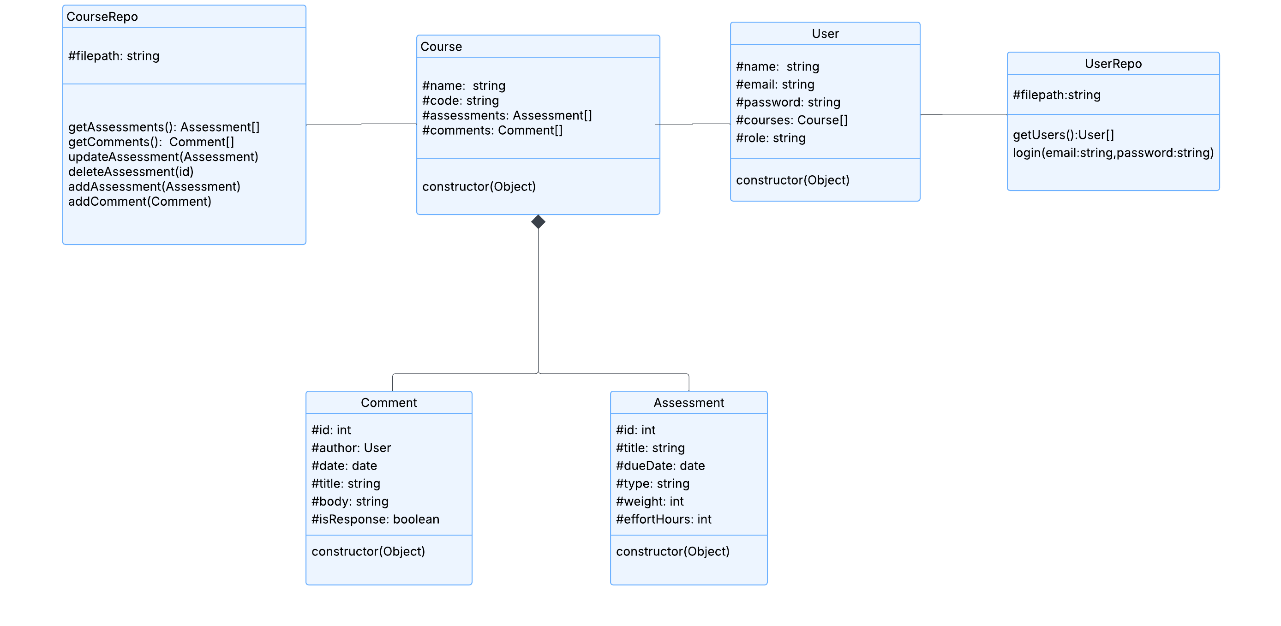

Services Class Diagram
Method | URL | Description
GET | api/courses/assessments | Returns the assessments for each course.
GET | api/courses/comments | Returns the comments for each course.
GET | api/courses | Returns courses
POST | api/[courseID]/assessments | Adds a new assessment and returns it having courseID.
GET | api/[courseID]/assessments | Returns the assessment by courseID.
GET | api/[courseID] | Returns course comments having courseID.
POST | api/[courseID]/comment | Adds a new comment and returns it having courseID.
PUT | api/[courseID]/assessments/[assessmentID] | Update the assessment by having the course ID for that assessment and assessment ID returns the updated one.
DELETE | api/[courseID]/assessments/[assessmentID] | Deletes the assessment by having the course ID of that assessment and the assessment ID.
POST | api/users | Used for login. Checks if user's email and password are within the system and are correct

Testing

Login
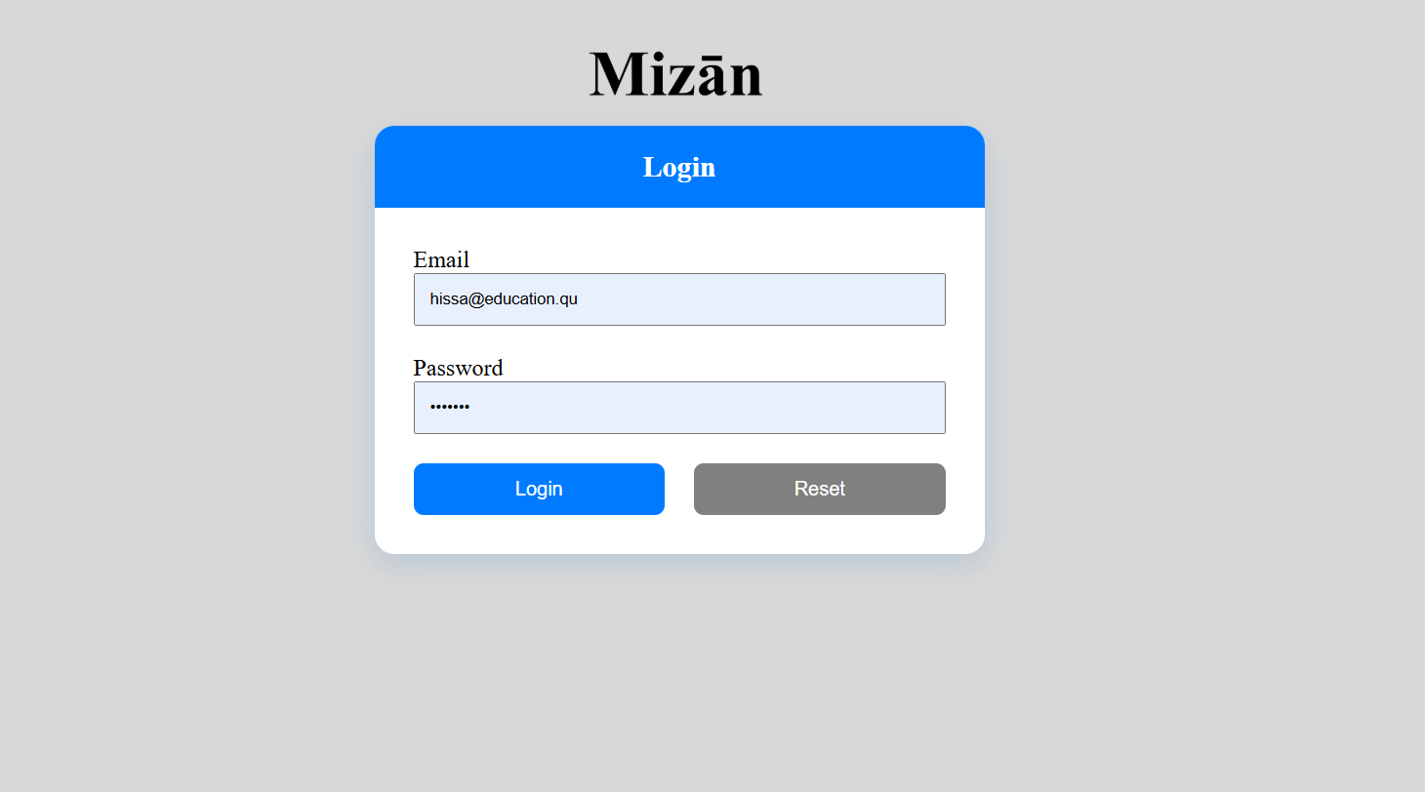

Add Assessment
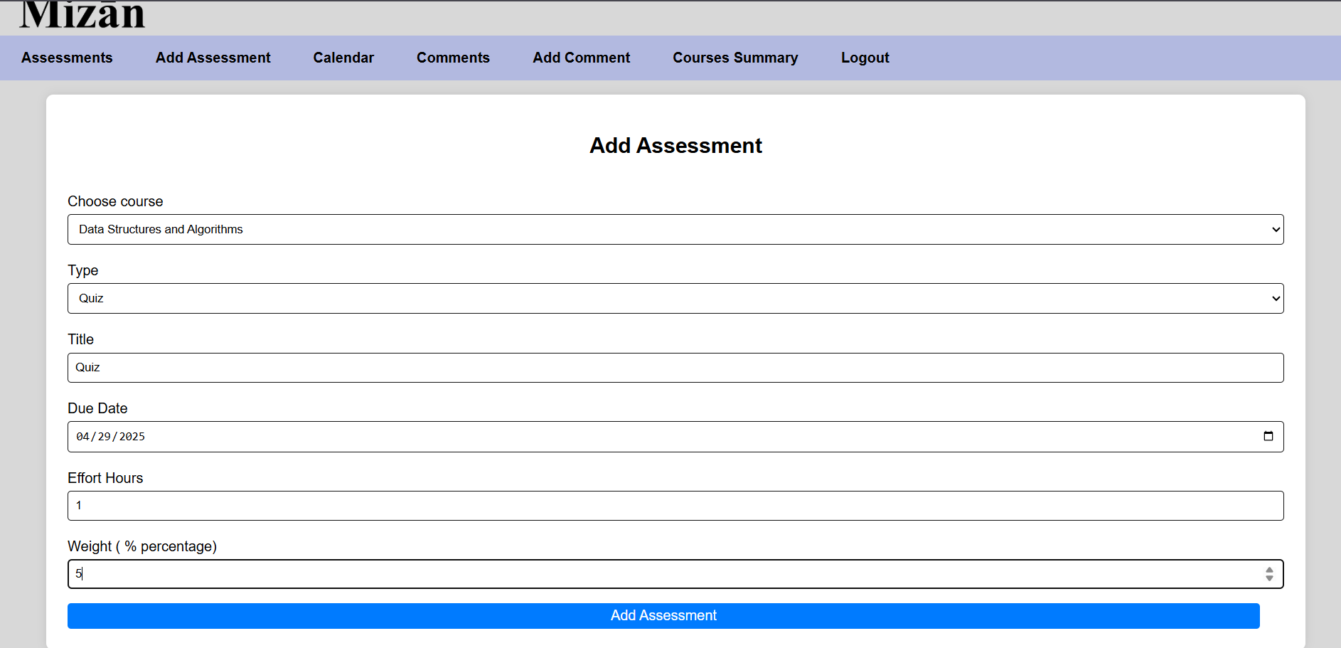

Update Assessment
Before updating:
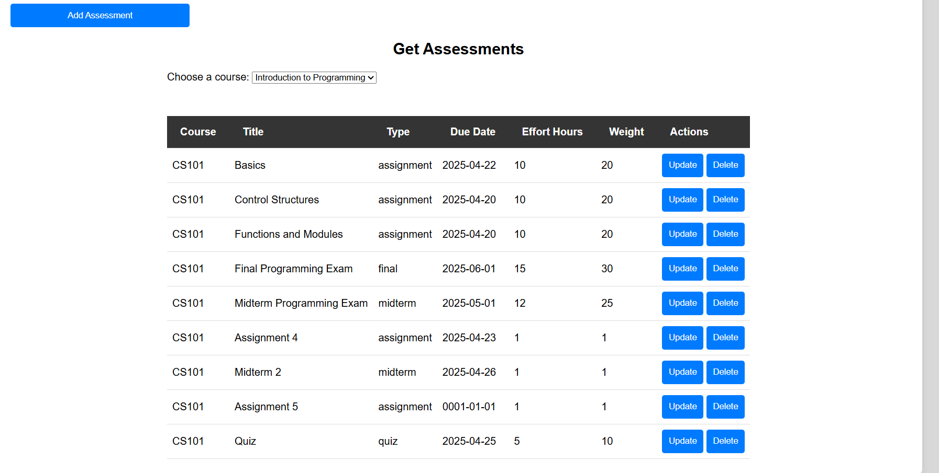
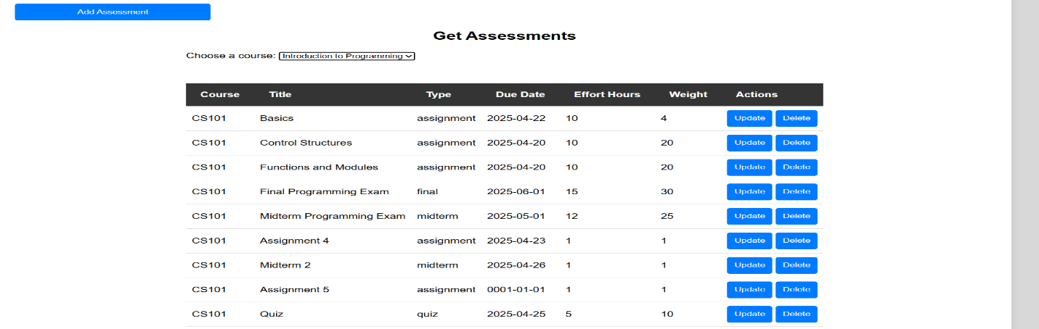
After updating the first row:

Delete Assessment

Before deleting:

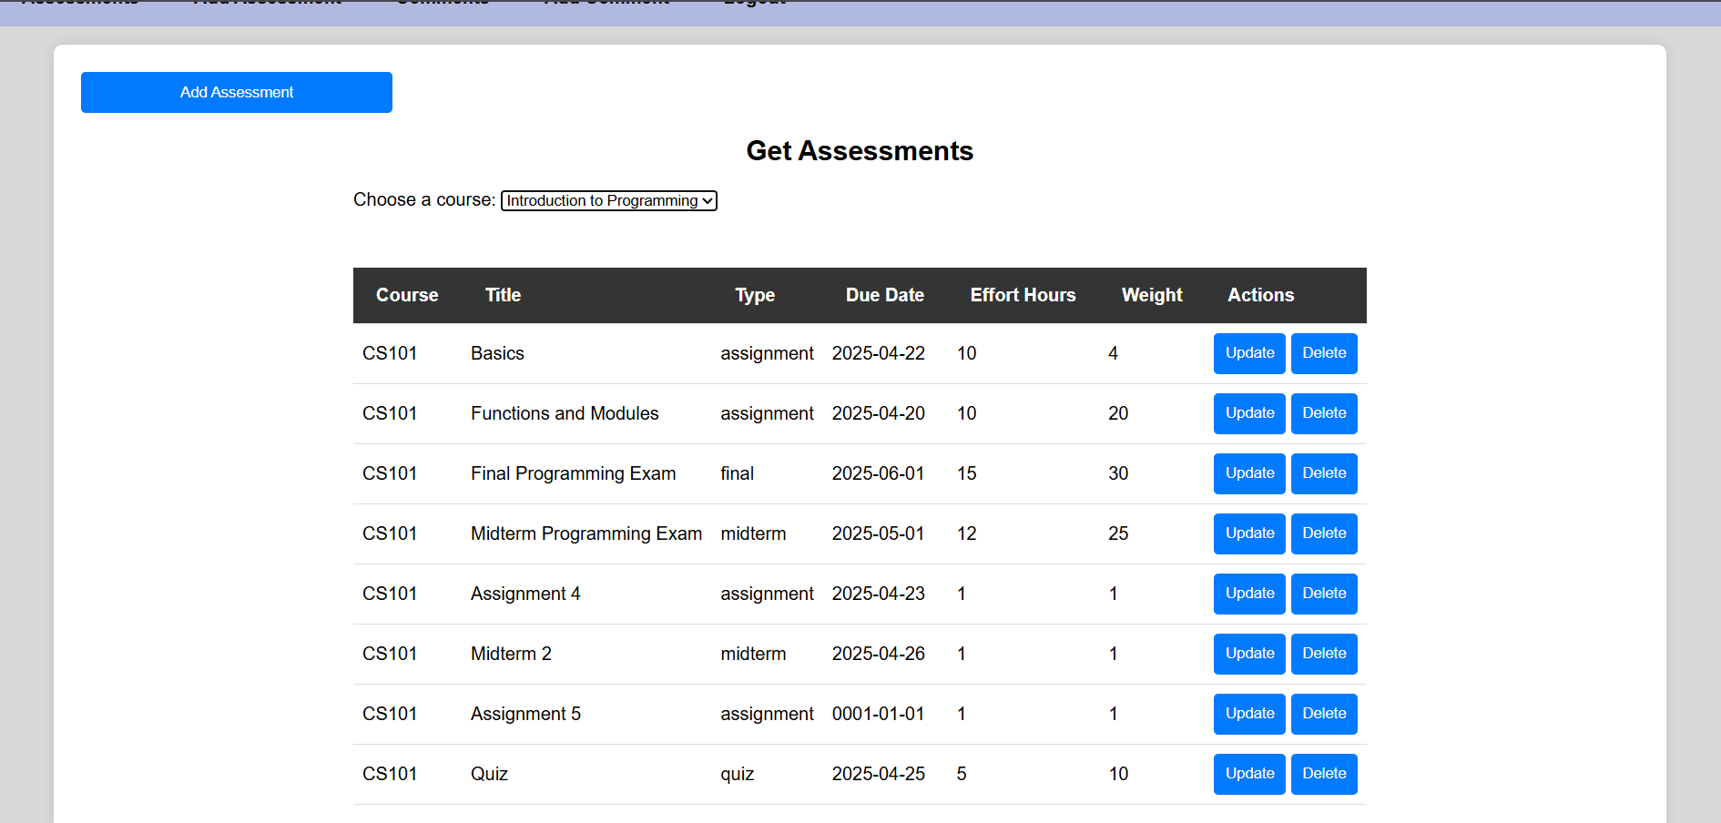
After deleting the second row:

Get Assessments
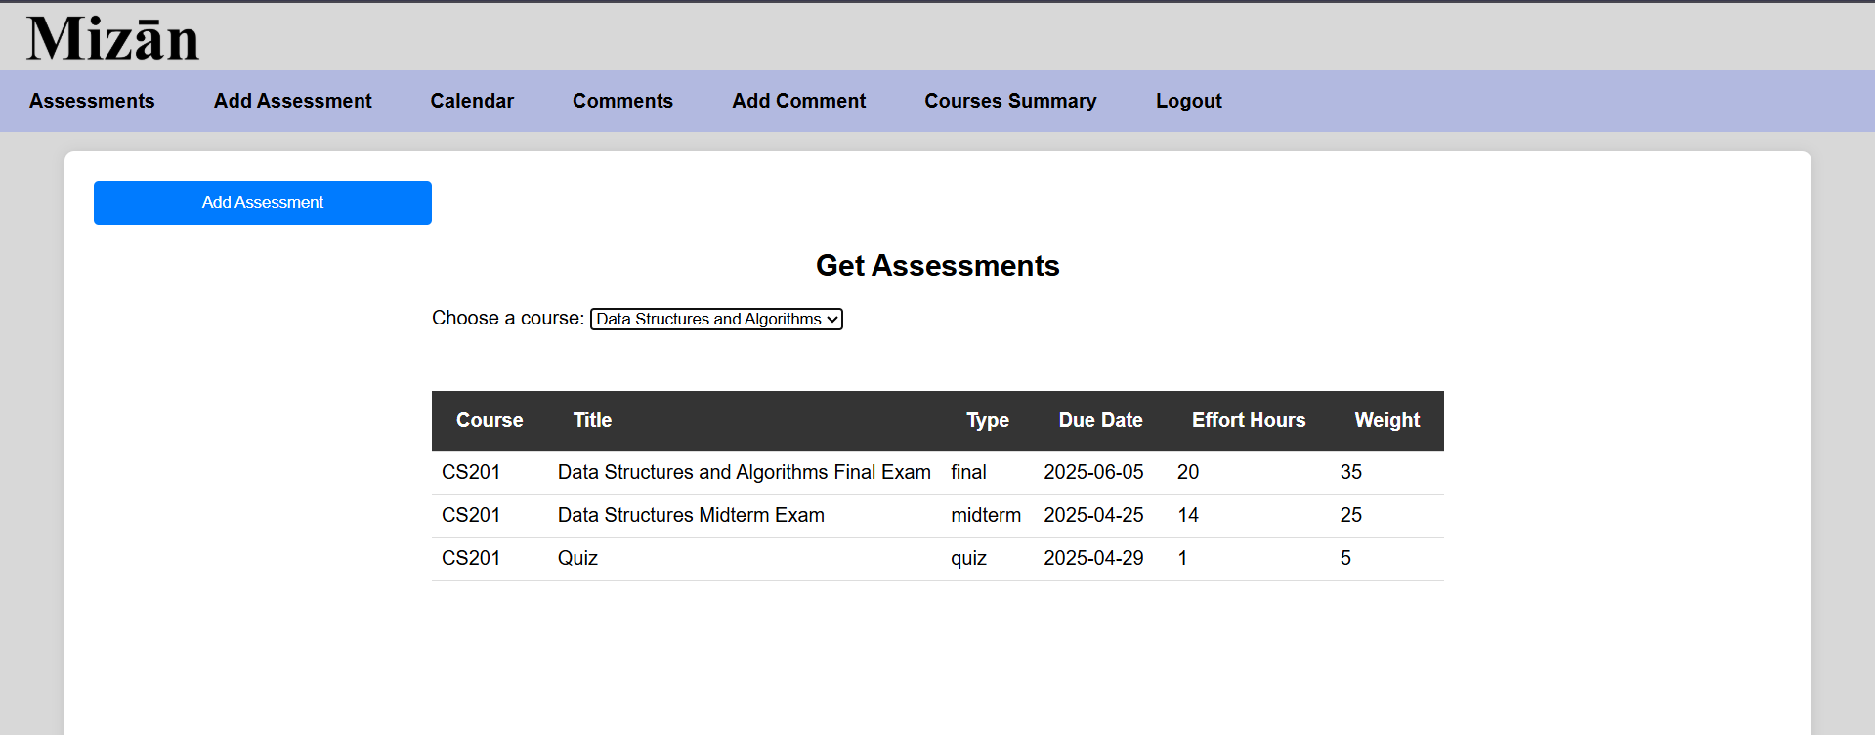

Student Assessments Calendar
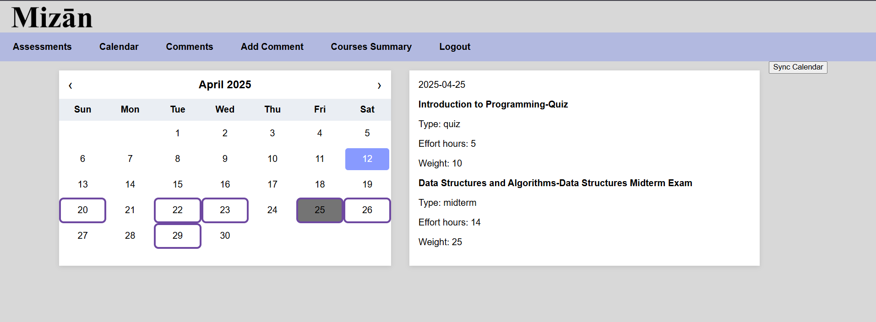

Add Course Comment
By students and coordinators:
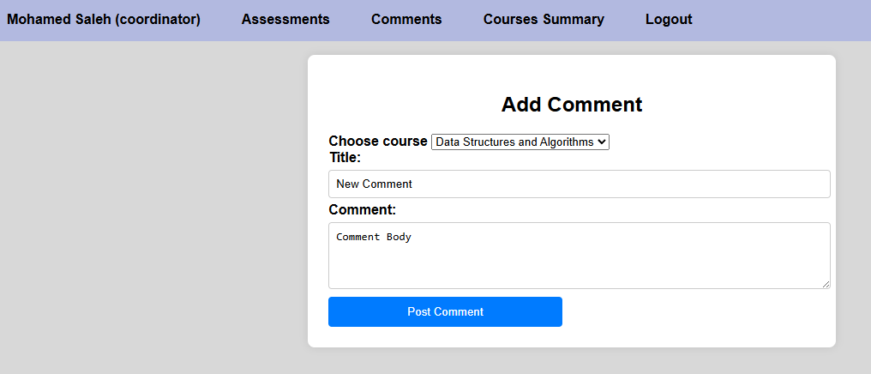

Adding respond by instructor:
Before adding respond to the last comment by Dina
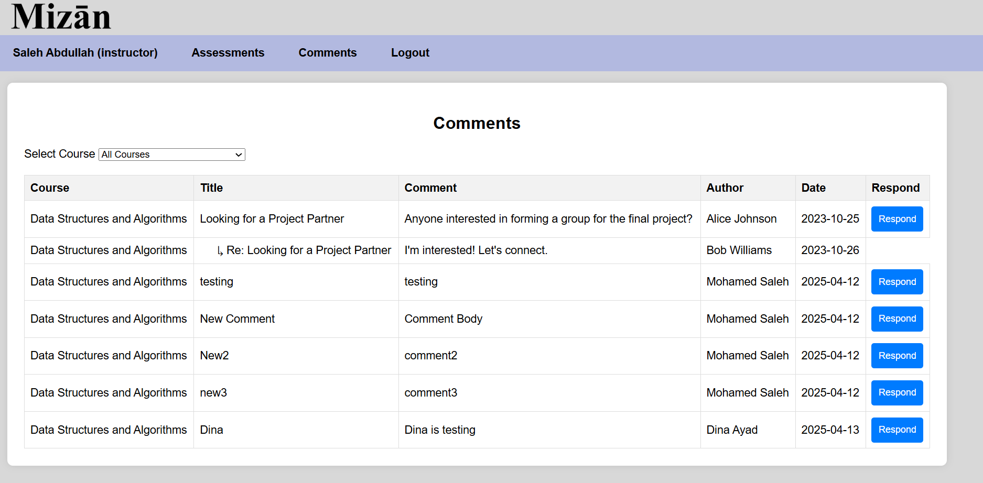

Adding respond to Dina’s comment
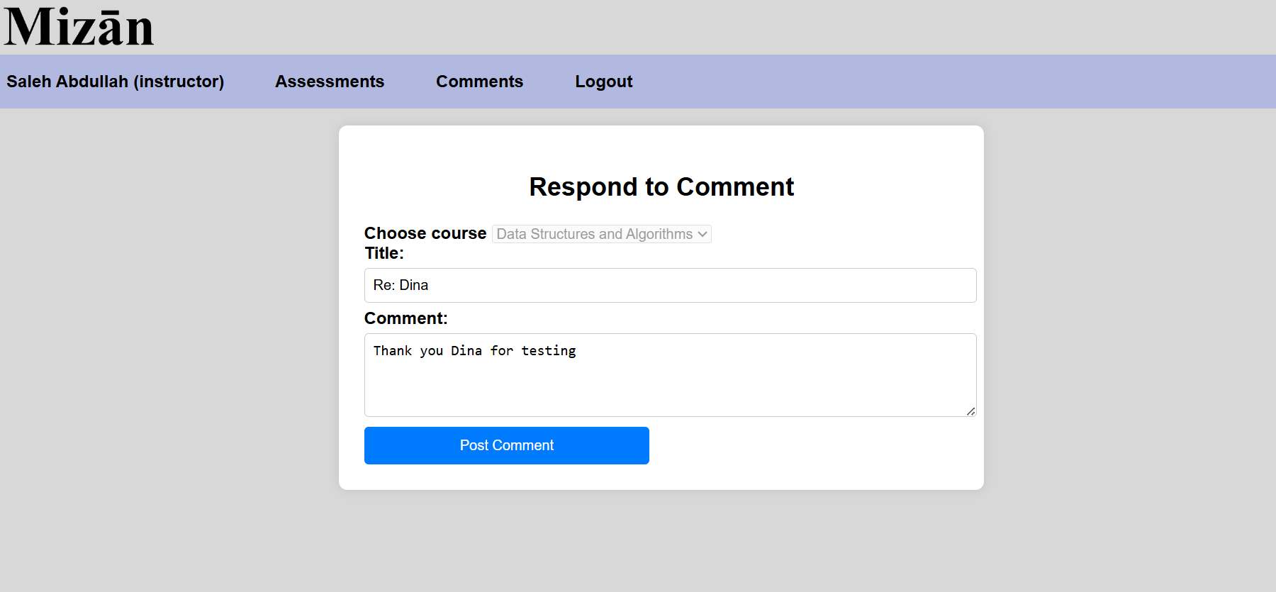

After adding the respond
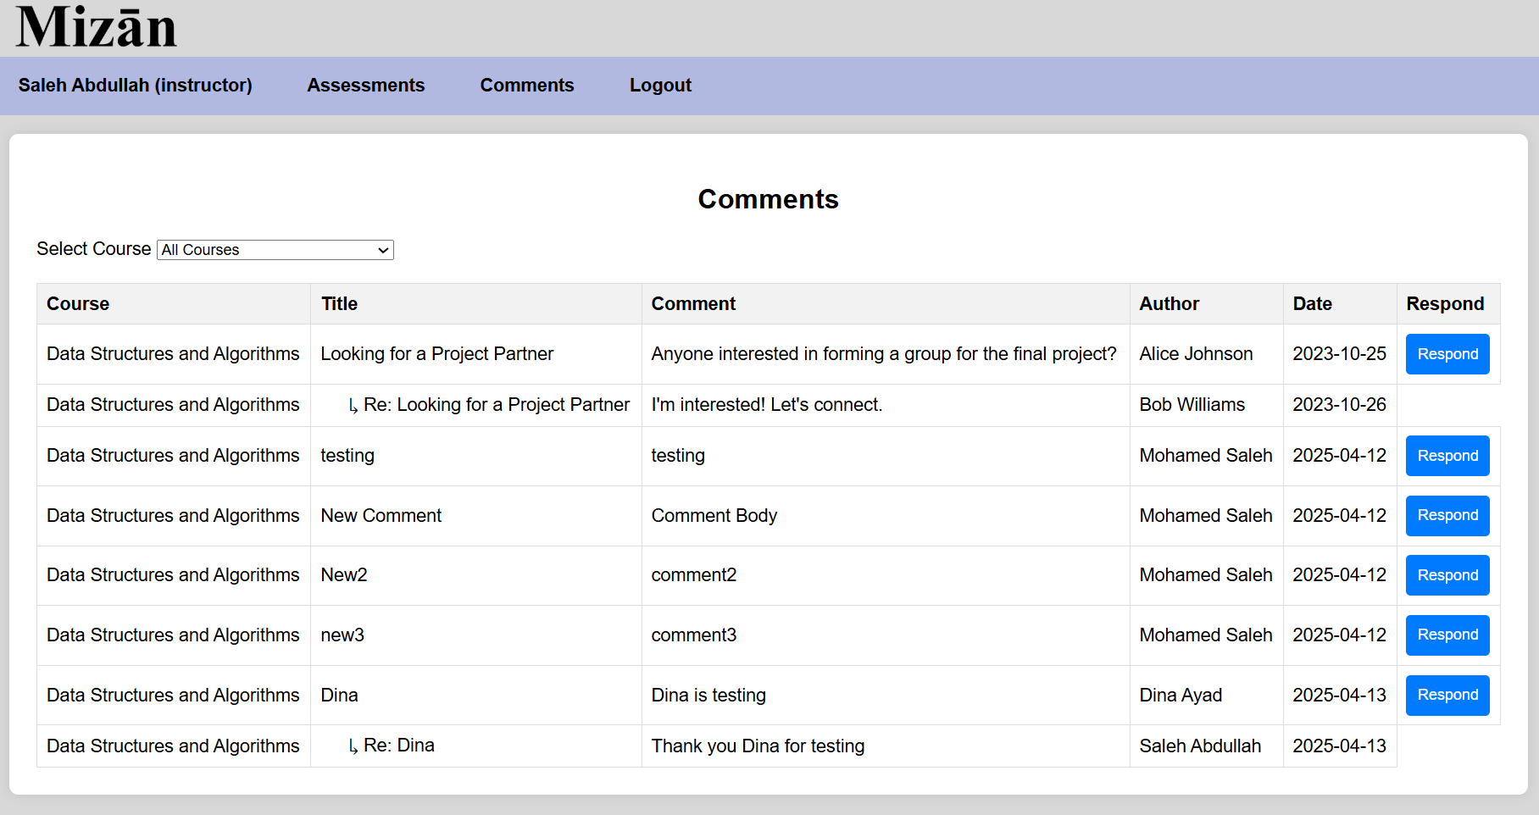

Get Course Comments
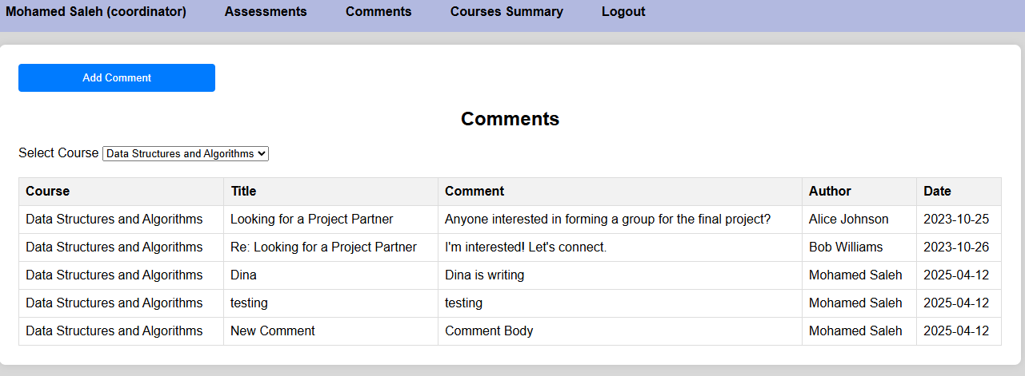

Courses Workload Summary Report
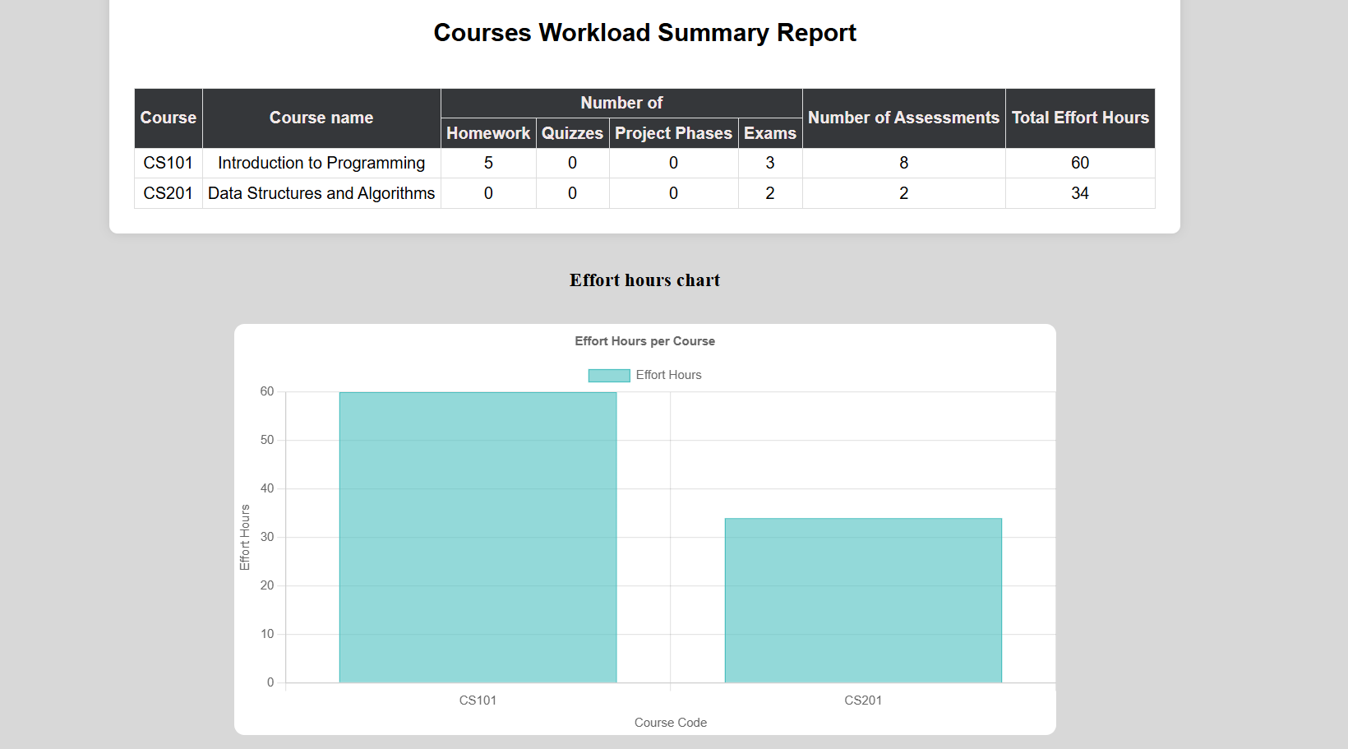

Summary of team member contributions
Member | Completed use cases / tasks
Tamara Bassim | Add assessment validation – Add and get assessment display – Add comment use case
Fatima Elzahra Mahgoub | Assessment calendar use case and display – Add assessment use case – Add comment use case
Dina Ayad | Login use case - Summary report use case – API services – Delete and Update Assessment – Add comment use case
Iman Khabaz | Get Comment use case - add and get comment display - API services – Add comment use case

